Ryan Galdamez

First of all I want to say Thank you to everyone who hosted us. You guys did an amazing job of making us feel at home. I truly enjoyed my time in Nepal and I will absolutely take my family there one day.
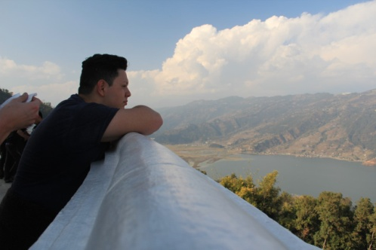
The Rotaract Club of New Road Pokhara members were awesome they did a great job of showing us the beautiful city of Pokhara. I was able to get very close to them because they were so loving and caring. One thing I learned from them was that they are very welling to help no matter in what way. For example they all were very aware of us and took care of us in whichever way they could. In Pokhara we did a lot; for example, the first two days we went to the 9th Rotaract Conference which was full of very talented young adults who are very willing to help the community. The next few days we went sightseeing, painting and delivered school supplies to a few schools. I remember giving the students the school supplies and the smile that came to their face really made me happy in the inside. I remember a quote I heard in Parbat by Antim Gurung and it stated, “You could go to a movie and have 3 hours of joy, but helping others is a happiness that will last a lifetime” and I truly believed those words. I also remember Hiking to the top of hill and seeing a big Buddha statue and then going up the stairs and seeing the whole city of Pokhara and my breath being taken away by the beauty of what I was seeing. Pokhara had so much to offer from a Five Star hotel to camping. The people that hosted us really did a great job of showing us what the city Pokhara really has to offer.
The last two days we stayed In Kathmandu with the Rotaract club of Rudramati. They also hosted us very good. I remember when we got there they took us to eat at a place where they order MoMo’s for us and they tasted very good and also sausage which was very good as well. They also took us to the Asha Project of the constructions of apartments and the painting of a park where many people go to hangout and have fun. I also remember eating where the construction site was and just seeing all the people there helping and doing a small part to help a city devastated by an earthquake two years ago. I also remember going to two schools and giving them schools supplies and they both received them with open arms. Kathmandu really showed me how close people get when there is devastation and no matter how bad the situation is life still goes on.
I learned a lot about myself in this trip because I was able to step out of my comfort zone and really engage with people I have never met before. But this trip really helped me come out of my shell and now I feel like I can take on any task put in front of me. Our friends from Kathmandu and Pokhara did such a great job of showing us Nepal that I feel like if I would have gone a lone and had done everything by myself I would have not experienced Nepal as I did with everyone that hosted us. This trip really made me appreciate what I have in my Country and because of this trip I was able to open my eyes to see what is really happening around the world. Now I have more motivation to help out our community and communities around the world because I know there is a lot of work to be done in order to get this world into shape.

